Experiment Number: 01

Title: Setup a wired LAN

PROBLEM STATEMENT

Setup a wired LAN using Layer 2 Switch and then IP switch of minimum four computers. It includes preparation of cable, testing of cable using line tester, configuration machine using IP addresses, testing using PING utility and demonstrate the PING packets captured traces using Wireshark Packet Analyzer Tool.

OBJECTIVES:

1. To understand the structure and working of various networks including the interconnecting devices used
in them.
2. To get hands on experience of making and testing cables

TYPES OF NETWORK
Common examples of area network types are:
LAN - Local Area Network
WLAN - Wireless Local Area Network
WAN - Wide Area Network
MAN - Metropolitan Area Network
SAN - Storage Area Network, System Area Network, Server Area Network, or
sometimes Small Area Network
CAN - Campus Area Network, Controller Area Network, or sometimes Cluster Area
Network
PAN - Personal Area Network
DAN - Desk Area Network

LAN - Local Area Network
A LAN connects network devices over a relatively short distance. A networked office building, school, or home usually contains a single LAN, though sometimes one building will contain a few small LANs (perhaps one per room), and occasionally a LAN will span a group of nearby buildings.

MAN-Metropolitan Area Network
A network spanning a physical area larger than a LAN but smaller than a WAN, such as a city. A MAN is typically owned and operated by a single entity such as a government body or large corporation.

WAN - Wide Area Network
As the term implies, a WAN spans a large physical distance. The Internet is the largest WAN,
spanning the Earth. A WAN is a geographically-dispersed collection of LANs. A network device called
a router connects LANs to a WAN. In IP networking, the router maintains both a LAN address and a
WAN address.

TYPES OF CABLES

Cable is the medium through which information usually moves from one network device to another. There are several types of cable which are commonly used with LANs. In some cases, a network will utilize only one type of cable, other networks will use a variety of cable types. The type of cable chosen for a network is related to the network's topology, protocol, and size. Understanding the characteristics of different types of cable and how they relate to other aspects of a network is necessary for the development of a successful network.

The following sections discuss the types of cables used in networks and other related topics.

- Unshielded Twisted Pair (UTP) Cable
- Shielded Twisted Pair (STP) Cable
- Coaxial Cable
- Fiber Optic Cable
- Cable Installation Guides
- Wireless LANs

Unshielded Twisted Pair (UTP) Cable

Twisted pair cabling comes in two varieties: shielded and unshielded. Unshielded twisted pair (UTP) is the most popular and is generally the best option for school networks

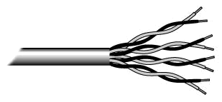

Fig.1. Unshielded twisted pair

The quality of UTP may vary from telephone-grade wire to extremely high-speed cable. The cable has four pairs of wires inside the jacket. Each pair is twisted with a different number of twists per inch to help eliminate interference from adjacent pairs and other electrical devices. The tighter the twisting, the higher the supported transmission rate and

the greater the cost per foot. The EIA/TIA (Electronic Industry Association/Telecommunication Industry Association) has established standards of UTP and rated six categories of wire (additional categories are emerging).

ategories of Unshielded Twisted Pair
Category |  | Speed |  | Use
1 |  | 1 Mbps |  | Voice Only (Telephone Wire)
2 |  | 4 Mbps |  | LocalTalk & Telephone (Rarely used)
3 |  | 16 Mbps |  | 10BaseT Ethernet
4 |  | 20 Mbps |  | Token Ring (Rarely used)
 |  | 100 Mbps (2 pair) |  | 100BaseT Ethernet
5
 |  | 1000 Mbps (4 pair) |  | Gigabit Ethernet
5e |  | 1,000 Mbps |  | Gigabit Ethernet
6 |  | 10,000 Mbps |  | Gigabit Ethernet

Unshielded Twisted Pair Connector

The standard connector for unshielded twisted pair cabling is an RJ-45 connector. This is a plastic connector that looks like a large telephone-style connector (See fig. 2). A slot allows the RJ-45 to be inserted only one way. RJ stands for Registered Jack, implying that the connector follows a standard borrowed from the telephone industry. This standard designates which wire goes with each pin inside the connector.

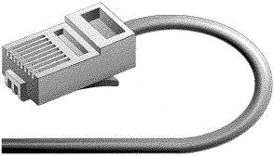

Fig. 2. RJ-45 connector
Shielded Twisted Pair (STP) Cable

Although UTP cable is the least expensive cable, it may be susceptible to radio and electrical frequency interference (it should not be too close to electric motors, fluorescent lights, etc.). If you must place cable in environments with lots of potential interference, or if you must place cable in extremely sensitive environments that may be susceptible to the electrical current in the UTP, shielded twisted pair may be the solution. Shielded cables can also help to extend the maximum distance of the cables.

Shielded twisted pair cable is available in three different configurations:

- Each pair of wires is individually shielded with foil.
- There is a foil or braid shield inside the jacket covering all wires (as a group).

- There is a shield around each individual pair, as well as around the entire group of wires (referred to as double shield twisted pair).

Coaxial Cable
Coaxial cabling has a single copper conductor at its center. A plastic layer provides insulation between the center conductor and a braided metal shield (See fig. 3). The metal shield helps to block any outside interference from




Fig. 3. Coaxial cable

Although coaxial cabling is difficult to install, it is highly resistant to signal interference. In addition, it can support greater cable lengths between network devices than twisted pair cable. The two types of coaxial

Thin coaxial cable is also referred to as thinnet. 10Base2 refers to the specifications for thin coaxial cable carrying Ethernet signals. The 2 refers to the approximate maximum segment length being 200 meters. In actual fact the maximum segment length is 185 meters. Thin coaxial cable has been popular in

Thick coaxial cable is also referred to as thicknet. 10Base5 refers to the specifications for thick coaxial cable carrying Ethernet signals. The 5 refers to the maximum segment length being 500 meters. Thick coaxial cable has an extra protective plastic cover that helps keep moisture away from the center conductor. This makes thick coaxial a great choice when running longer lengths in a linear bus network. One disadvantage of thick coaxial is that it does

Coaxial Cable Connectors

The most common type of connector used with coaxial cables is the Bayone-Neill-Concelman (BNC) connector (See fig. 4). Different types of adapters are available for BNC connectors, including a T-connector, barrel connector, and terminator. Connectors on the cable are the weakest points in any network. To help avoid problems with your network, always use the BNC connectors that crimp, rather


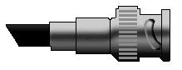

Fig. 4. BNC connector

Fiber Optic Cable

Fiber optic cabling consists of a center glass core surrounded by several layers of protective materials (See fig. 5). It transmits light rather than electronic signals eliminating the problem of electrical interference. This makes it ideal for certain environments that contain a large amount of electrical interference. It has also made it the standard for connecting networks between

Fiber optic cable has the ability to transmit signals over much longer distances than coaxial and twisted pair. It also has the capability to carry information at vastly greater speeds. This capacity broadens communication possibilities to include services such as video conferencing and interactive services. The cost of fiber optic cabling is comparable to copper cabling; however, it is

The center core of fiber cables is made from glass or plastic fibers (see fig 5). A plastic coating then cushions the fiber center, and kevlar fibers help to strengthen the cables and prevent breakage. The outer insulating jacket made of teflon or PVC.

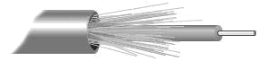

Fig. 5. Fiber optic cable

There are two common types of fiber cables -- single mode and multimode. Multimode cable has a larger diameter; however, both cables provide high bandwidth at high speeds. Single mode can provide more distance, but it is more expensive.

NETWORK TOPOLOGY

The study of network topology recognizes seven basic topologies: ^{[3]}

- Point-to-point topology
- Bus (point-to-multipoint) topology
- Star topology
- Ring topology
- Tree topology
- Mesh topology
- Hybrid topology

This classification is based on the interconnection between computers — be it physical or logical.

The physical topology of a network is determined by the capabilities of the network
access devices and media, the level of control or fault tolerance desired, and the cost
associated with cabling or telecommunications circuits.

Bus

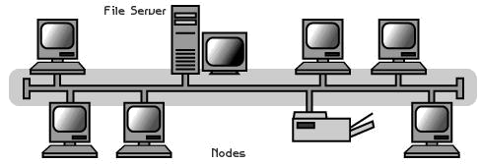

Bus network topology

In local area networks where bus topology is used, each machine is connected to a single

cable. Each computer or server is connected to the single bus cable through some kind of

connector. A terminator is required at each end of the bus cable to prevent the signal from

bouncing back and forth on the bus cable. A signal from the source travels in both

directions to all machines connected on the bus cable until it finds the MAC address or IP

address on the network that is the intended recipient. If the machine address does not

match the intended address for the data, the machine ignores the data. Alternatively, if the

data does match the machine address, the data is accepted. Since the bus topology consists of only one wire, it is rather inexpensive to implement when compared to other

topologies. However, the low cost of implementing the technology is offset by the high

cost of managing the network. Additionally, since only one cable is utilized, it can be the

single point of failure. If the network cable breaks, the entire network will be down.

Star
A star topology is designed with each node (file server, workstations, and peripherals) connected directly to a central network hub, switch, or concentrator (See fig. 2).

Data on a star network passes through the hub, switch, or concentrator before continuing to its destination. The hub, switch, or concentrator manages and controls all functions of the network. It also acts as a repeater for the data flow. This configuration is common with twisted pair cable; however, it can also be used with coaxial cable or fiber optic cable.

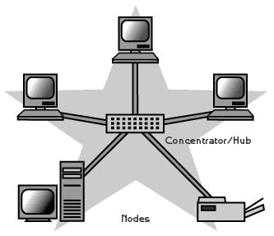

Advantages of a Star Topology

- Easy to install and wire.
- No disruptions to the network when connecting or removing devices.
- Easy to detect faults and to remove parts.

Disadvantages of a Star Topology

- Requires more cable length than a linear topology.
- If the hub, switch, or concentrator fails, nodes attached are disabled.
- More expensive than linear bus topologies because of the cost of the hubs, etc.

Tree or Expanded Star

A tree topology combines characteristics of linear bus and star topologies. It consists of groups of star-configured workstations connected to a linear bus backbone cable (See fig.). Tree topologies allow for the expansion of an existing network, and enable schools to configure a network to meet their needs.

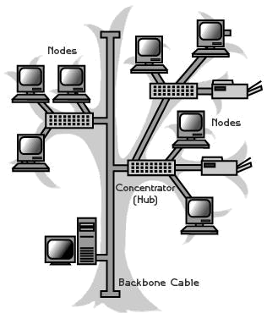

Advantages of a Tree Topology

- Point-to-point wiring for individual segments.
- Supported by several hardware and software venders.

Disadvantages of a Tree Topology

- Overall length of each segment is limited by the type of cabling used.
- If the backbone line breaks, the entire segment goes down.
- More difficult to configure and wire than other topologies.

PROCEDURE

There are generally three main types of networking cables: straight-through, crossover, and rollover cables. Each cable type has a distinct use, and should not be used in place of another. So how do you know which cable to use for what you need?

The Purpose of Straight-Through Cables

Straight-through cables get their name from how they are made. Out of the 8 pins that exist on both ends of an Ethernet cable, each pin connects to the same pin on the opposite side. Review the diagram below for a visual example:



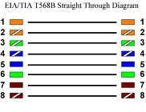

OR

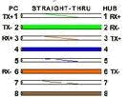

Notice how each wire corresponds to the same pin. This kind of wiring diagram is part of the 568A standard. The 568B standard achieves the same thing, but through different wiring. It is

generally accepted to use the 568A standard as pictured, since it allows compatibility with certain telephone hardware- while 568B doesn’t.

Straight-through cables are primarily used for connecting unlike devices. A straight-through cable is typically used in the following situations:

Use a straight-through cable when:

- Connecting a router to a hub

- Connecting a computer to a swtich

- Connecting a LAN port to a switch, hub, or computer

Note that some devices such as routers will have advanced circuitry, which enables them to

use both crossover and straight-through cables. In general, however, straight-through cables will not connect a computer and router because they are not “unlike devices.”

The purpose of Crossover Cables
Crossover cables are very similar to straight-through cables, except that they have pairs of wires that crisscross. This allows for two devices to communicate at the same time. Unlike straight-through cables, we use crossover cables to connect like devices. A visual example can be seen below:

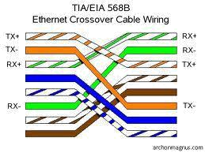

Notice how all we did was switch the orange-white and green-white wires, and then the orange and green wires. This will enable like devices to communicate. Crossover cables are typically used in the following situations:

Use a crossover cable when:

- Connecting a computer to a router

- Connecting a computer to a computer

- Connecting a router to a router

- Connecting a switch to a switch

- Connecting a hub to a hub

While the rule of thumb is to use crossover cables with like devices, some devices do not

follow standards. Others provide support for both types of cables. However, there is still something that both crossover and straight-through cables can’t do.

The Purpose of Rollover Cables

Rollover cables, like other cabling types, got their name from how they are wired. Rollover cables essentially have one end of the cable wired exactly opposite from the other. This

essentially “rolls over” the wires- but why would we need to do such a thing? Rollover cables, also called Yost cables, usually connect a device to a router or switch’s console port.

This allows a programmer to make a connection to the router or switch, and program it as needed. A visual example can be seen below:

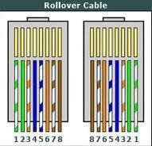

Notice that each wire is simply “rolled over.” These types of cables are generally not used very much, so are usually colored differently from other types of cables.

APPLICATION

- Most networks in the real world use the above-mentioned devices to create networks.

CONCLUSION
Thus, we have successfully understand the structure and working of various networks
including hands on experience of making and testing cables

